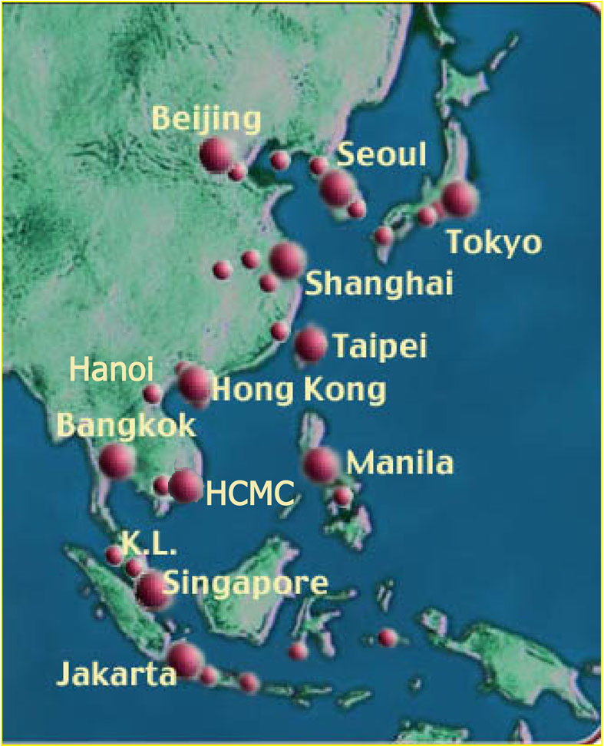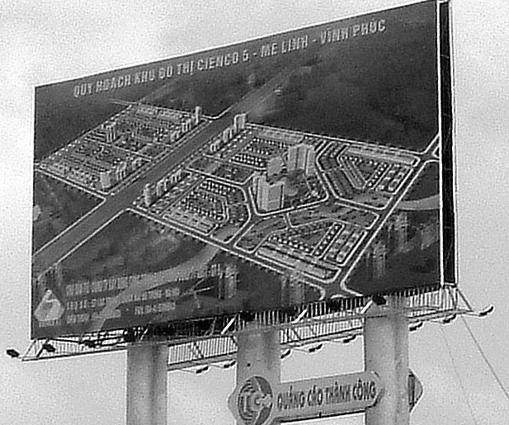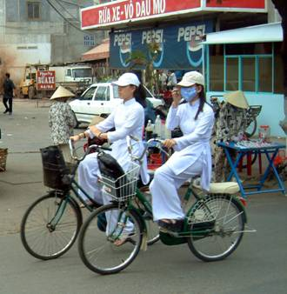

亞洲城市的全球化 GLOBALIZING CITIES IN ASIA
授課：台灣大學建築與城鄉研究所 黃麗玲Liling Huang
時間：星期四晚間6:30-9:20
地點：城鄉所工綜館311
Email: liling@ntu.edu.tw
Tel: (O)0233665972, (M) 0925703500
課程助教：待聘
Office Hour: 星期三早上9:30-12:00或電話約定
課程結構
城市是你我生活的舞台，也是發動全球化變遷過程的引擎。到2005年，全球有一半的人口居住在都市中，而預計在2025年全球的都市人口將超過三分之二。在台灣，都市化比例已超越百分之八十。整體而言，亞洲國家，例如中國、越南、印度等，正是這一波的全球化過程中，都市化最為快速的國家。伴隨著都市化與經濟成長，亞洲城市成為全球資本流動的熱區。全球化所帶來的時空壓縮、跨界生產與流動的現象，正在亞洲城市中加速進行。這些由跨界動力所催動的城市網絡間，既充滿競爭，又有不同層級的合作。然而，在亞洲國家尋求全球化路徑、創造經濟成長的耀眼表現下，隱藏著許多的社會與空間的矛盾：區域與階級的差異跨大、都市社會被政治衝突、宗教以及種族矛盾所分裂。亞洲複雜的都市化過程與全球化模式，正是都市與區域研究的重要新興課題。

本課程安排主要分成兩個部分。第一個部分介紹亞洲城市由資本與菁英所打造的全球化與空間再結構過程。這些主題包括區域經濟重組、城市的競爭與網絡化、英雄式的新都心與都市鉅型計畫的崛起、城市擴張以及鉅型都市區域內部的發展差距、由跨界的資本與菁英美學的都市意識型態所打造的新隔離主義的烏托邦、被新自由主義政策所引領的城市空間私有化趨勢、以及相對的都市貧窮問題等。我們討論的城市與區域將包括亞洲中（1）先進的經濟發展國家日本；(2)已分手揚鑣的前「東亞四小龍」經濟體；(3) 新崛起的中國大陸主要城市；(4)經濟全球化中的後進國家：包括東南亞的菲律賓的馬尼拉、泰國的曼谷、馬來西亞的吉隆坡、越南河內及胡志明市，以及柬埔寨的金邊等。這幾個東南亞城市的發展將讓帶領我們檢視全球化城市中的同質化與異質化的面貌。

課程的第二個主題是全球城市中的勞工或家戶流動。城市中的移民與移工的數量的背景往往反映出一個城市的全球化位階。城市的政策與移民接近空間的權利也考驗當地社會對於新社會成員的接受度，挑戰著城市作為一個cosmopolitan的可能性。在前半部我們討論了以由上至下的外國資本流入所主導、以及跨界經濟整合所重塑的都市形貌之後，我們接下來將以由下而上的觀點，在Globalization from below架構下，討論亞洲區域內部，以及向外其他經濟區域的流動，包含全球城市中的勞工、家庭成員與家戶的流動、公民權等問題。

課程目標
1.使學生掌握全球化的政治、經濟與文化邏輯以及這些動力，熟悉全球城市的主要概念
2.使學生理解全球化衝擊下都市空間生產模式的改變、進一步指稱亞洲全球化城市的特性
3.使學生從結構以及作用者的觀點，對東亞、中國大陸、東南亞的各主要城市所採取的同質與異質發展路徑進行比較
4.定位台灣或台北在亞洲區域經濟與家戶流動中所扮演的角色
5.理解亞洲區域內部的國際移工與配偶的流動型態、跨界流動所帶來的公民權的議題以及相對的國家管制等議題

課程連結
本課程將來將相銜接的課程包括「亞洲城市實習」、「全球化與日常生活」、「亞太地區的公民社會與地方創造」等

進行方式
本課程三小時課程中，前一小時為講師授課，介紹每週課程主題的主要概念與理論發展，主要為以下列為Introduction部分的讀物。第二小時為同學報告所規定的讀物，也就是Required reading 部分。多為案例介紹，以有助於比較研究與深入探討。第三個小時為討論時間。請同學踴躍發問與討論。Recommended reading 做為同學進一步研究各主題以及寫作期末作業時的參考閱讀資料。

課程要求
- 課程六點三十分準時上課。若您不能維持準時出席的守則，請不要選修這堂課。若您有特殊狀況不能出席或遲到，請於上課前通知課程助教。本課程歡迎旁聽。但請旁聽生遵守上課時間規定。
- 本課程主要為研究所高年級以及博士班設計。課程繁重，尤其以讀物以英文為主。碩一學生請衡量修課時間與能力。
- 每節上課兩天前繳交一頁A4讀書心得（reflection），email給課程助理。由課程助理整理後在上課前一天傳給所有修課學生。不收逾期作業。
- 出席率、報告內容以及討論發言的參與很重要。佔期末總成績之40%。
- 平時作業成績為總成績之30%。
- 期末報告為總成績之30％。不收逾期報告，除非不可抗力原因。
- 期末作業若有抄襲情況，學期成績將以不及格計。

課程大綱
Week 1 (9/20)
課程介紹Class Introduction

Week 2 (9/27)
Changing Political Economy and Regional Geography

Introduction:
1. Friedmann, John, and Goetz Wolff. 1982. “World City Formation: An Agenda for Research and Action.” International Journal of Urban and Regional Research (IJURR). 6(3):309-345..
2. Friedmann, John. 1986. “The World City Hypothesis.” Development and Chang, 17(1): 69-83.

Required reading:
1. Friedmann, John. 1997. “World City Futures: the Role of Urban and Regional Policy in the Asia Pacific Region.” In Cities and Design, No. 2/3, Dec., 1-25. (Chinese translation)（傅約翰，1997。「世界城市的未來：都市與區域政策在亞太地區的角色」，杜歆穎譯，城市與設計學報。第二、三期，1997年12月，1-25頁。）
2. Douglass, Mike. 2000. “Mega-Urban Regions and World City Formation: Globalization, the Economic Crisis and Urban Policy Issues in Pacific Asia.” Urban Studies, 17:12, 2317-2337.
3. Sassen, Saskia. 2006. “Locating Cities on Global Circuits.” Originally from Environment and Urbanization (2002), reprinted in The Global Cities Reader. Neil Brenner and Roger Keil (eds.). London: Routledge. 89-95,
4. King, Anthony D. 2006. “World Cities: Global? Postcolonial? Postimperial? Or Just the Result of Happenstance? Some Cultural Comments.” The Global Cities Reader. Neil Brenner and Roger Keil (eds.). London: Routledge. pp320-324,

Recommended reading:
1. Scott, Allen J. , John Agnew, Edward W. Soja and Michael Stoper. 2001. “Global City-Regions.” in Global City Regions: Trends, Theory, Policy, edited by Allen J. Scott. New York: Oxford Press. 12-29,

Week 3 (10/4)
From Colonial to World Cities

Introduction:
1. King, Anthony D. 2006. “Building, Architecture, and the New International Division of Labor.” Originally from Urbanism, Colonialism and the World-Economy (1991). Reprint in The Global City Reader. Pp 196-202. Edited by Neil Brenner and Roger Keil. London: Routledge.

Required reading:
1. Ho, Kong Chong. 1997. “From Port City to City State: Forces Shaping Singapore’s Built Environment.” Pp 212-233. in Culture and the City in East Asia. edited by Won Bae Kim, Mike Douglass, Sang-Chuel Choe, and Kong Chong Ho (eds) Oxford: Clarendon Press.
2. Shatkin, Gavin. 2006. Colonial Capital, Modernist Capital, Global Capital: the changing political symbolism of urban space in Metro Manila, the Philippines.pp 89-118. Edited by K. C. Ho and Hsin-Huang Michael Hsiao. Taipei: Center for Asia –Pacific Area Studies. RCHSS, Academic Sinica, Taipei, Taiwan
3. Logan, William. 2006. “The Cultural Role of Capital Cities: Hanoi and Hue, Vietnam.” pp49-70. in Capital Cities in Asia-Pacific: Primacy and Diversity. K. C. Ho and Hsin-Huang Michael Hsiao (eds). Taipei: Center for Asia –Pacific Area Studies. RCHSS, Academic Sinica, Taipei, Taiwan

Recommended reading:
1. Chakravorty, Sanjoy. 2000. “From Colonial City to Globalizing City? The Far-from-complete Spatial Transformation of Calcutta.” in Globalizing Cities: A New Spatial Order? Edited by Peter Marcuse and Ronald van Kempen. London: Blackwell. 56-77.
2. Drakakis-Smith, David. 1992. “A Historical Geography of Pacific Asia.” In Pacific Asia. London: Routledge. 17-44.

Week 4 (10/11)
Geopolitics, Networking and Formation of Global City Region

Introduction:
1. 科司特，2000。第二章，新經濟： 資訊主義全球化，網絡化。資訊時代：經濟，設化與文化。第一卷：網絡社會的崛起。台北：唐山。頁85-155。
2. 科司特，2000。第三章，網絡企業：資訊化經濟的文化、制度與組織。資訊時代：經濟，設化與文化。第一卷：網絡社會的崛起。台北：唐山。頁171-218。
(Castells. The Rise of Network Society. Chapter 2& 3)

Required reading:
1. Wang, Jenn-Hwan. 2004. “World City Formation: Geopolitics and Local Political Process: Taipei’s Ambiguous Development.” International Journal of Urban and Regional Research (IJURR), Vol. 28.2. June 2004, 1-17.
2. 周素卿，陳東升，2001。「後進者的全球化：東南亞台灣企業地域生產網絡的建構與對外投資經驗」。都市與計畫，第二十八卷第四期。頁421-459.
(Jou, Sue-Ching and Dung-Sheng Chen. 2001. Later Comer’s Globalization : Taiwan’s Experiences in FDI and Reproduction of Territorial Production Networks in Southeast Asia. Vol.28. No. 4: 421-460.)
3. Tyner, James A. 2002. “Global City and Circuits of Global Labor: the case of Manila, Philippines.” in Filipinos in Global Migrations: At home in the world? Edited by Filomeno V. Aguilar, Jr. MOST: UNESCO. Manila: Philippine Migration Research Network. 60-85.

Recommended reading:
1. 梁銘華，2003。「台灣『南向政策』的政治與經濟關係」。收於台灣與東南亞南向政策與越南新娘，蕭新煌編。台北：中央研究院，亞太區域研究專題中心。頁43-63。
2. Chen, Xiangming. 2006. “Beyond the Reach of Globalization: China’s border regions and cities in transition.” in Globalization and Chinese City. Edited by Fulong Wu. London: Routledge. 22-46.

Week 5 (10/18)
World City Hierarchy, Developmental State and Diverse Paths to Global Cities

Introduction:
1. Hill, Richard Child and June Woo Kim. 2000. “Global Cities and Developmental States: New York, Tokyo and Seoul.” Urban Studies 37 (12) 2167-2195.
2. Douglass, Mike. 1994. “The ‘Developmental State’ and the Newly Industrialized Economies of Asia,” Environment and Planning A, 26(4) 543 – 566.

Required reading:
1. Machimura, Takashi.1992. “The Urban Restructuring Process in Tokyo in the 1980s: Transforming Tokyo into a World City.” original from IJURR. Reprint in The Global City Reader. Neil Brenner and Roger Keil (eds.). London: Routledge. 146-153.
2. Olds, Kris and Henry Wai-chung Yeung. 2006. Pathways to Global City Formation: A View from the Developmental State of Singapore. Originally from Review of International Political Economy (2004), reprinted in The Global Cities Reader. edited by Neil Brenner and Roger Keil. London: Routledge. 392-399.
3. 周志龍，2001。「跨界經濟、時空的接合與國土再結構策略：亞洲四小龍的再結構比較」。都市與計畫，第二十八卷第四期。頁461-494。

Recommended reading:
1. 王振寰，2002。東亞「世界城市」的不同路徑：漢城與台北。台灣社會研究季刊。第四十七期，頁 85-141。台北：唐山出版社。(Wang, Jenn-hwan. 2002 “Different Routes towards World City Formation in East Asia: Seoul and Taipei Compared.” Vol. 47: 85-141. Taiwan: A Radical Quarterly of Taiwan Social Studies）.
2. Taylor, Bruce and Kwok, R. Yin-Wang. 1989. “From Export Center to World City: Planning for the Transformation of Hong Kong.” APA Journal, 1989 (Summer), 309-321.

Week 6 (10/25)
Inequality and Livability in Mega Urban Region

Introduction
1. Fainstein, Susan S. 2006. “Inequality in Global City Regions.” In Global City Regions: Trends, Theory, Policy. edited by Allen J. Scott. New York: Oxford Press. 285-298.
2. Douglass, Mike. 2001. “Globalization and the ‘New’ Urban Poverty in Pacific Asia: Rethinking Concepts, Explanations and Approaches” Workshop on the Evolving Role of Development Banks. Sponsored by East-West Center and the Globalization Research Center, Honolulu, April 25, 2001. The Japanese Center of Hawaii, Honolulu, Hawaii.

Required reading
1. Douglass, Mike. 2005. “Globalization, Mega-Urban Region and Environment in Pacific Asia.” Paper presented in Ritsumeikan Asian Pacific Conference on the Limits of the Asia Pacific City in the 21st Century: the Intersection of Environmental, Social and Cultural Issues. Ritsumeikan Asia Pacific University and Ritsumeikan Center for Asia Pacific Studies, Beppu, Japan, 29-30 January, 2005.
2. Douglass, Mike, Trung Quang Le, Cameron Kawika Lowery, Hao Thien Nguyen, Anh Nguyrn Pham, Nghi Dong Thai and Hernani Yulinawati. 2004. “The Livability of Mega-Urban Regions in Southeast Asia: Bangkok, Ho Chi Minh City, Jakarta and Manila Compared.” Paper presented in International Conference on the Growth Dynamics of Mega-Urban Regions in East and Southeast Asia, Singapore, 24-25 June, 2004, total 38 pages.
3. Huang, Liling. Forthcoming. “ Taipei: Post-industrial Globalization
‘Taipei: Post Industrial Globalization. ” In Gavin W. Jones and Mike Douglass (eds), The Rise of Mega-Urban Regions in Pacific Asia (working title). Singapore: Singapore University Press.

Recommended Reading:
1. Waley, Paul. 2000. “Tokyo: Pattern of Familiarity and Partitions of Difference. In Globalizing Cities: A New Spatial Order?” in Globalizing Cities: A New Spatial Order? Peter Marcuse and Ronald van Kempen (eds). London: Blackwell. 127-157.
2. Breitung, Werner and Mark Gunter. 2006. “Local and Social Change in a Global City: The Case of Hong Kong.”. In Globalizing the Chinese City, edited by Fulong Wu. London: Routledge. 80-107

Week 7 (11/1)
Chinese Cities, Intelligence Group and New Urbanism

Introduction:
1. Ma, Laurence J. C. and Fulong Wu. 2005. “Chapter 1. Restructuring the Chinese City: Diverse Process and reconstituted spaces.” pp1-20, in Restructuring the Chinese City: Changing Society, Economy and Space. Laurence J. C. Ma and Fulong Wu (eds). London: Routledge.
2. Wu, Fulong. 2006. “Chapter 1. Globalization and China’s New Urbanism.” In Globalizing the Chinese City, edited by Fulong Wu. London: Routledge. 1-19.

Required readings:
1. Wei, Yehua Dennis and Danlin Wu, 2006. “State Policy and the Globalization in Beijing: Emerging Themes” Habitat International (30) 377-395. Amsterdam: Elsevier.
2. Olds, Kris. 1997. “Globalizing Shanghai: the Global Intelligence Corp” and the Building of Pudong. Cities, 14 (2): 109-123
3. Wei, Albert Wing Tai. 2006. Place Promotion and Iconography in Shanghai’s Xingtiandi. Habitat International (30) 245-260. Amsterdam: Elsevier.
4. Huang, Tsung .Yi. Michelle. 2004. “Chapter 7, From Ally Houses to High-rises: what happened to the lived space? “ in Walking between Slums and Skyscrapers: Illusions of Open space in Hong Kong, Tokyo and Shanghai. Hong Kong: Hong Kong University Press. 111-118.

Recommended Reading:
1. Walker, Richard & Daniel Buck. 2007. “The Chinese Road, Cities in the Transition to Capitalism.” New Left Review. July 2007. 39-66.
2. Giroir, Guillaune. 2006. “A Globalized Golden Ghetto in a Chinese Garden: the Fountainebleau Villas in Shanghai. in Globalization and Chinese City. Edited by Fulong Wu. London: Routledge. 208-225.

Week 8 (11/8)
Primate Cities, Civil Society in Southeast Asia

Introduction:
1. Ho, K. C. and Hsin-Huang Michael Hsiao. 2006. “ Globalization and Asia-Pacific Capital Cities: Primary and Diversity.” in Globalization and Asia-Pacific Capital Cities: Primary and Diversity, K. C. Ho and Hsin-Huang Michael Hsiao (eds). Taipei: Center for Asia –Pacific Area Studies. RCHSS, Academic Sinica, Taipei. 3-25.
2. Douglass, Mike. 2006. “The Globalization of Capital Cities: Civil Society and Neo-liberal State and the Reconstruction of Urban space in Asia Pacific.” Globalization and Asia-Pacific Capital Cities: Primary and Diversity, in K. C. Ho and Hsin-Huang Michael Hsiao (eds). Taipei: Center for Asia –Pacific Area Studies. RCHSS, Academic Sinica, Taipei, Taiwan. 28-45.

Required Reading:
1. Sirat, Morshidi. 2006. “Kuala Lumpur: Primacy, Urban System and Rationalizing Capital City Functions.”. in Globalization and Asia-Pacific Capital Cities: Primary and Diversity, K. C. Ho and Hsin-Huang Michael Hsiao (eds.). Taipei: Center for Asia –Pacific Area Studies. RCHSS, Academic Sinica, Taipei, Taiwan. 71-88.
2. Pornpan Boonchuen. 2002. Globalisation and Urban Design: Transformations of Civic Space in Bangkok. Mike Douglass, ed. “Special Issue on Globalization and Civic Space in Pacific Asia,” International Development Planning Review, 24:4, November.
3. Shatik, Gavin. 2006. “’Fourth World’ Cities in the Global Economy: the Case of Phnom Penh, Cambodia.”. in The Global Cities Reader. Neil Brenner and Roger Keil (eds.). London: Routledge. 210-216.

Recommended reading:
1. Pornpan Boonchuen and K. C. Ho. 2006. “Bangkok as Capital and Emergent World City.” Edited by K. C. Ho and Hsin-Huang Michael Hsiao. Taipei: Center for Asia –Pacific Area Studies. RCHSS, Academic Sinica, Taipei. 120-135.

Week 9 (11/16) (校慶放假)
Week 10 (11/22)(課程演講與交流)
Week 11 (11/29)
World City Competition, Urban Design and Mega Urban Projects

Introduction:
1. Olds, Kris. 2001. “Globalization and the Development of Pacific Rim Mega Projects.” in Globalization and Urban Changes: Capital, Culture and Pacific Rim Mega-Projects. London: Oxford University. 17-34.

Required reading:
- Marshall, Richard. 2002. “Urban Project in a Global World.” in Emerging Urbanity: Global Urban Projects in the Asia Pacific Rim. London: Spon Press. 9-27
2. Jou, Sue-Ching. 2005. Domestic Politics in Urban Image Creation: Xingyi as the Manhattan of Taipei. in Globalizing Taipei: The Political Economic of spatial Development Edited by Reginald Yin-Wang Kwok. London: Routledge. 20-140.
3. Marshall, Richard. 2002. The making of a Malaysian Capital: Putrajaya and the Multimedia Super Corridor. in Emerging Urbanity: Global Urban Projects in the Asia Pacific Rim. London: Spon Press. 169-190

Recommended reading:
1. Marshall, Richard. 2002. “The Idea of the City.” in Emerging Urbanity: Global Urban Projects in the Asia Pacific Rim. London: Spon Press. 191-215.
2. Douglass, Mike. 1993. “The ‘New’ Tokyo Story: Restructuring Space and the Struggle for Place in a World City,” in Kuniko Fujita and Richard Child Hill (eds.), Japanese Cities in the Global Economy: Global Restructuring and Urban-Industrial Change. Philadelphia: Temple Univ. Press. 83-119.

Week 12 (12/6)
Asia Economic Crisis, Privatization and Privatopia

Introduction:
1. McGee T. G. 2002. “Restructuring the Southeast Asian City in an Era of Volatile Globalization.” Asian Journal of Social Science, 30:1, 8-27.
2. Clammer, John. 2003. “Globalization, Class, Consumption and Civil Society and South-East Asia.” Urban Studies, Vo. 40. 403-419.

Required Reading:
1. Douglass, Mike. 2002. “Re-Inventing Pacific Asia Cities: Vision and Realities after the Crisis.” pp 46-67. In International Conference: Re-inventing Global Cities. 11. Nov. 2000. Hong Kong. Convention and Exhibition Center. Hosted by The center of Urban Planning and Environmental Management. The University of Hong Kong.
2. Douglass, Mike and Liling Huang. 2007. “Globalizing the City in Southeast Asia: Utopia on the Urban Edge – the Case of Phu My Hung, Saigon.” The International Journal of Asia Pacific Studies. Electronic Journal, Malaysia: Penerbit Universiti Sains Malaysia.
3. Kim, Wan Beo. 2001. “Re-positioning of City-Region: Korea after the Crisis.” in Global City Regions: Trends, Theory, Policy, edited by Allen J. Scott. New York: Oxford Press. 263-284.

Recommended reading:
1. Shatkin, Gavin. 2007. “The City and the Bottom Line: urban mega-projects and the privatization of planning in Southeast Asia.” Environment and Planning A. March, 2007.

Week 13 (12/13) 專題演講. To be announced.
Week 14 (12/20)
New Governance, Economy Resilience and Local Participation

Introduction:
- 夏鑄九， 2007. 做為社會動力的社區與城市：全球化下對社區營造的一點理論上的思考。台灣社會研究季刊。台北：唐山出版社。65(3): 227-248. (Hsia, Chu-joe. 2007. “Communities and Cities as Social Dynamics: Theorizing Community Empowerment in Globalization” in Taiwan: A Radical Quarterly of Taiwan Social Studies 65(3): 227-248.)

Required reading:
1. Douglass, Mike. 2002. “From Global Intercity Competition to Co-operation for Livable City and Economic Resilience in Pacific Asia.” Environmental and Urbanization, No. 1. April 2002. 53-68.
2. Douglass, Mike with Orathai Ard-Am and Ik Ki Kim. 2002. “Urban Poverty and the Environment: Social Capital and State-Community Synergy in Seoul and Bangkok.” in Peter Evans, ed., Livable Cities? The Politics of Urban Livelihood and Sustainability. Berkeley: University of California Press. 29-61.
3. Huang, Liling. 2006. “Urban Politics and Spatial Development: the Emergence of Participatory Planning in Taipei,” in R.Y Kwok ed., Globalizing Taipei . London: Routledge. 78-98

Recommended reading:
- Purcell, Mark. 2003. “Citizenship and the Right to the City: Re-imagining the Capital City Order.” International Journal of Urban and Regional Research (IJURR) September. Vol. 27:(3) 564-90.
2. Hsiao, H. H. Michael and Hwa-Jen Liu. 2002. “Collective Action toward a Sustainable City.” in Peter Evans, ed., Livable Cities? The Politics of Urban Livelihood and Sustainability. Berkeley: University of California Press. 67-94.

Week 15 (12/27)
Migration, Citizenship and Rights to the City

Introduction:
1. Sandrecock, Leonie.1998. “Towards Cosmopolis: a Post Modern Agenda,” from Towards Cosmopolis: Planning for Multicultural Cities and Regions. London: John Wiley and Sons. .

Required Reading:
1. Huang, Liling and Mike Douglass. forthcoming “Foreign Workers and the Production of Community Space: Taipei’s Little Philippines.” In Amrita G. Daniere and Mike Douglass (eds.) Building Urban Communities (working title), London: Routledge.
2. Law, Lisa. 2002. “Defying Disappearance: Cosmopolitan Public Spaces in Hong Kong,” Urban Studies, 39(9):1625-1645.
3. Yeoh, Brenda .S.A. and Huang, Shirlina.1998. “Negotiating Public Space: Strategies and Styles of Migrant Female Domestic Workers in Singapore,” Urban Studies, 35(3):583-602.

Recommended Reading:
1. 王宏仁，吳美瑤。2006。「霸權空間的破綻─以台北火車站為例」論文發表於「跨界流離：全球化時代移民／工與社會文化變遷」學術研討會，世新大學社會發展研究所主辦。六月十八至十九日，台北：世新大學舍我樓。
2. 王志弘，2006。「移／置認同與空間政治：桃園火車站週邊消費族裔地景研究」台灣社會研究季刊。第61卷，3月號。頁149-203。台北：唐山出版社。

Week 16 (1/3)
Regional Dynamics, Migration and Global Householding

Introduction:
1. Lin, George C. and Pauline H. M. Tse.2005, “Flexible Sojourning in the Era of Globalization: Cross-Border Population Mobility in the Hong Kong-Guang Dong Border Region.” International Journal of Urban and Regional Research （IJURR）. Vol. 29 (4) 867-894.
2. Douglass, Mike. 2006. “Global Householding in Pacific Asia,” International Development Planning Review, Special Issue on ‘Global Householding in East and Southeast Asia,’ 28:4. 421-477

Required reading:
1. Porio, Emma .2007. “Filipino Migration and Global Householding: A Preliminary Review.” Philippine Studies Quarterly. July, 2007. The Ateneo de Manila University Press.
2. Toyoto, Mika. 2006. “Ageing and Transnational Householding: Japanese Retirees in Southeast Asia.” International Development Planning Review. 515-533
3. Huang, Liling. 2007. “Going Global: Householding and Demographic Transition of Taiwan.” Philippine Studies Quarterly. July, 2007. The Ateneo de Manila University Press.

Recommended readings:
1. Huang, Liling. 2006. “A World without Strangers? Taiwan’s New Households in the Nexus of China and Southeast Asia Relations,” International Development Planning Review, 28(4):447-473.
2. 藍佩嘉, 2002. 「跨越國界的生命地圖：菲籍家務移工的流動與認同」。台灣社會研究季刊第四十八卷，12月號，頁169-218。台北：唐山出版社。(Lan, Pei-Chia. 2002. “A Transnational Topography for the Migration and Identification of Filipina Migrant Domestic Workers.” Vol .48 (4): 168-218. Taiwan: A Radical Quarterly of Taiwan Social Studies）.

Week 17 (1/10)
Nation State and Migration Control, and Local State Practices

Introduction:
1. Douglass, Mike. 1999. “Unbundling National Identity – Global Migration and the Advent of Multicultural Societies in East Asia,” Asian Perspectives, 23:3, 79-128.
2. Holston, James. 2001. “Urban Citizenship and Globalization.” in Global City Regions: Trends, Theory, Policy, edited by Allen J. Scott. New York: Oxford Press. 325-348.

Required reading:
1. Pak, Katherine Tegtmeyer. 2003. “Foreigners Are Local Citizens Too.” In Mike Douglass and Glenda S. Roberts (eds.) Japan and Global Migration: Foreign Workers and the Advent of a Multicultural Society. Honolulu: University of Hawaii Press. 244-274.
2. Yeoh, Breada S. A. and T. C. Chang. 2001. “Globalising Singapore: Debating the Transnational Flows in the City.” Urban Studies. Vol. 38. No.7. 1025-1044.
3. 曾嬿芬, 2006. 誰可以打開國界的門？移民政策的階級主義。台灣社會研究季刊，第61卷。頁 37-107。 （Yen-Fen Tseng 2006. “Who can be ‘Us’? Class Selection in Immigration Policy.” Vol. 61:37-107. Taiwan: A Radical Quarterly of Taiwan Social Studies）.

Recommended Reading:
1. Castles, Stephen. 2001. “International Migration and the Nation-State in Asia.” in The Philippines as Home: Settlers and Sojourners in the Country. Edited by Maruja M. B. Asis. MOST: UNESCO. Philippines Migration Research Network. 167-197.

