課程代號：408 10500, 408 10510
課程名稱：肌內效貼紮、肌內效貼紮實習
學分數：各一學分
課程說明： 肌內效貼紮為近年來盛行於物理治療界或運動界的貼紮療法，其治療成功之關鍵在於對人體動作的瞭解及軟組織解剖位置與功能的熟識。藉由物理治療師的手法與肌內效貼紮的彈性，可引導軟組織至其最佳狀況位置，以舒緩臨床症狀，增進關節功能。本課程探討常發生傷害的數個人體動作，並練習相關的肌內效貼紮技巧，期使學習者能利用這些技巧來強化專業能力，並引導學生熟習相關肌肉及其作用。本課程期末應繳交一份肌內效貼紮研究的團隊報告。

非同步教學課程網頁：http://www.pt.ntu.edu.tw/hmchai/ElasticTaping/Index.htm

授課對象：物理治療學系一年級學生
授課時間：每週二下午13:20~15:10、每週四上午10:00~12:00
授課地點：公衛大樓二樓215教室
主授教師︰柴惠敏
辦公室：公衛大樓三樓309室
電話：3366-8140
E-Mail：hmchai@ntu.edu.tw

教學目標：學生在修習本課程後，應能
1. 了解物理治療師常用貼布的種類及其應用。
2. 熟記40條常發生傷害的肌肉之接點、走向、及作用。
3. 認識常見的姿勢或動作傷害及其貼紮技巧，並探討其作用。
4. 熟悉臨床研究技巧，並能口頭報告及小組討論。

計分方式：
肌內效貼紮：團隊報告60% (含口頭報告、修正後的電子檔)；兩次肌肉報告20%；上課表現20%
肌內效貼紮實習：期末實習考試70% (跑檯)；上課表現30%

主要參考書:
1. Tortora G.J., Grabowski S.R., 2003. Principles of Anatomy and Physiology, 10th ed. New York, NY, USA: Wiley. [ISBN:0471224723]
2. Neumann, DA. (ed), 2010. Kinesiology of the Musculoskeletal System: Foundations for Rehabilitation, 2nd ed. Philadelphia, PA, USA: Mosby-Elsevier. [ISBN:978-0-323-03989-5]
3. Magee DJ, 2005. Orthopedic Physical Assessment, 5th ed. Philadelphia, PA, USA: Mosby-Elsevier. [ISBN: 9781416031093]
4. 鄭悅承, 2007。軟組織貼紮技術。台北，合記。
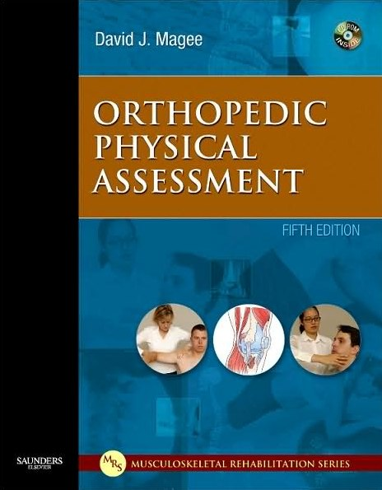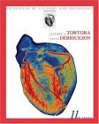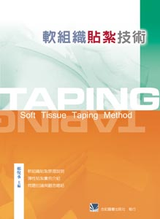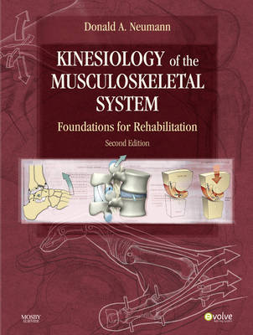

課程進度：
日 期 | 講 演 內 容 | 實 習 內 容
99/ 09/ 14 | Course orientation | Tape extensibility test
99/ 09/ 21 | Overview of elastic taping skills | Basic taping skill
99/ 09/ 28 | Overuse injuries following poor posture (I) | Taping for upper back
99/ 10/ 05 | Overuse injuries following poor posture (II) | Taping for low back
99/ 10/ 12 | Experimental research methodology | Discussion for group project
99/ 10/ 19 | Ankle sprain and its taping | Taping for ankle and foot
99/ 10/ 26 | Running movements and injuries | Taping for foot and knee
99/ 11/ 02 | Jumping movements and injuries | Taping for thigh and groin region
99/ 11/ 09 | Mechanical properties of muscle | Therasuit
99/ 11/ 16 | Overuse injuries in keyboard users | Taping for hand and fingers
99/ 11/ 23 | Mechanical properties of collagenous tissues | Taping for forearm and elbow joint
99/ 11/ 30 | Throwing movements and injuries | Taping for shoulder region
99/ 12/ 07 | Statistics | Statistics
99/ 12/ 14 | McConnell taping; | Taping in alternative therapy
99/ 12/ 21 | Group project report
99/ 12/ 28 | Group project report
100/ 01/ 04 | Practice Examination (期末實習考試)

肌肉時間:每次上課前，講演15分鐘
日期 | 肌肉 | 組別
99/ 09/ 14 | - trapezius: upper, middle, and lower  - levator scapulae  - rhomboid: minor and major | 1
99/ 09/ 21 | - erector spinae  - longissimus  - multifidus | 2
99/ 09/ 28 | - rectus abdominis  - obliquus externus abdominis and obliquus internus abdominis  - transversus abdominis | 3
99/ 10/ 05 | - triceps surae: gastrocnemius and soleus  - tibialis anterior and posterior  - peroneus longus and brevis | 4
99/ 10/ 12 | Discussion for group project
99/ 10/ 19 | - quadriceps femoris  - hamstrings: semitendinosus, semimembranosus, and biceps femoris  - popliteus | 5
99/ 10/ 26 | - adductor magnus and longus  - sartorius  - gracilis | 6
99/ 11/ 02 | - extensor carpi radialis longus & brevis  - extensor digitorum communis  - extensor carpi ulnaris | 1
99/ 11/ 09 | - biceps brachii  - brachialis  - triceps brachii | 2
99/ 11/ 16 | - rotator cuff: supraspinatus, infraspinatus, teres minor, and subscapularis  - teres major and minor  - coracobrachialis | 3
99/ 11/ 23 | - brachioradialis  - flexor carpi radialis and ulnaris  - palmaris longus | 4
99/ 11/ 30 | - pectoralis: major and minor  - serratus anterior  - deltoid: anterior, middle, and posterior fibers | 5
99/ 12/ 07 | 1. iliopsoas muscle  2. gluteus maximus, medius, and minimus  3. latissimus dorsi | 6

